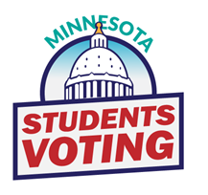
Students Voting 2024 Tally Worksheet

CANDIDATES | PARTY | VOTES
Donald J. Trump and JD Vance | REPUBLICAN
Kamala D. Harris and Tim Walz | DEMOCRATIC-FARMER-LABOR
Chase Oliver and Mike ter Maat | LIBERTARIAN PARTY
Robert F. Kennedy Jr. and Nicole Shanahan | WE THE PEOPLE
Jill Stein and Samson Kpadenou | GREEN PARTY
Claudia De la Cruz and Karina Garcia | SOCIALISM AND LIBERATION
Rachele Fruit and Dennis Richter | SOCIALIST WORKERS PARTY
Cornel West and Melina Abdullah | JUSTICE FOR ALL
Shiva Ayyadurai and Crystal Ellis | INDEPENDENT
WRITE-IN | WRITE-IN
 | TOTAL VOTES

